Question 1: Banker’s Algorithm – Deadlock Avoidance
Consider a system consisting of five processes (P0, P1, P2, P3, P4) and three resource types (A), (B), (C)and (D). The total number of instances of each resource type is 15, 11, 10 and 11, respectively.
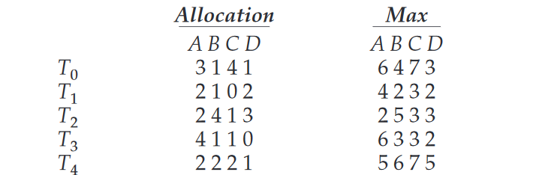
Answer the following:
a) Calculate the Need Matrix for all five processes using the formula:
b) Calculate the Available vector using the total resources and the current Allocation Matrix.
c) Apply the Banker’s Algorithm to determine whether the system is in a safe state. If it is safe, identify one possible safe sequence and show the steps involved in arriving at it.
d) If a request from thread T4 arrives for (2,2,2,4), can the request be granted immediately? Apply the Banker’s Algorithm to verify whether granting the request would leave the system in a safe state. Clearly justify your answer.

Question 2: Disk Scheduling Algorithms

Consider a disk with 200 tracks numbered from 0 to 199. The disk read-write head is currently positioned at track 100. The following disk requests are waiting to be serviced:
55, 58, 39, 18, 90, 160, 150, 38, 184
Calculate the total number of tracks traversed by the disk head using each of the following disk scheduling algorithms:
i) FCFS (First-Come, First-Served)
ii) SSTF (Shortest Seek Time First)
iii) SCAN
iv) LOOK
v) C-SCAN (Circular SCAN)
vi) C-LOOK (Circular LOOK)
Instructions for solving:
a) Show the order in which the requests are serviced for each algorithm.
b) Draw a neat diagram illustrating the head movement for each algorithm. Clearly mark the track numbers and the direction of movement.
c) Calculate the total head movement in tracks for each algorithm, showing the individual movements and the final total.
d) For SCAN, LOOK, C-SCAN, and C-LOOK, assume that the initial direction of head movement is towards the higher-numbered tracks.

Question 3: Deadlock Recovery
Deadlocks can occur in an operating system when processes wait indefinitely for resources held by one another. Once a deadlock has been detected, the operating system must take appropriate measures to recover from it.
a) Explain the different methods used for recovering from a deadlock.
b) Discuss process termination as a deadlock recovery method. Explain the two approaches to process termination and discuss the factors that should be considered when selecting a process for termination.
c) Explain resource preemption as a deadlock recovery method. Discuss the issues of victim selection, rollback, and starvation.
d) Compare process termination and resource preemption in terms of their advantages, disadvantages, and suitability for different situations.

